SEDAS
Social Engineering Defence and Awareness System
Technical / Programmer Manual
MIS5320 Applied IS Project — Part B · Assessment 3 Deliverable 2
Document type | Developer-oriented technical manual
System version | 0.1.0 (MVP)
Team | Ashraful Islam (240135); Huzaifa Iqbal (240220); Sonu (250001); Dominic Kipchirchir (240401)
Supervisor | Dr Chandana Withana
Repository | github.com/ailinkon/MIS5320-SEDAS-CyberProjectB
Audience | Developers and technical maintainers

1. System Overview and Objectives

1.1 Purpose
SEDAS is an integrated defence platform against social engineering attacks in a higher-education context. Where conventional phishing defences address only the technical vector, SEDAS combines automated detection with human-layer intervention and institutional governance, on the basis that social engineering exploits human judgement rather than technical vulnerability alone.

1.2 Objectives
- Detection — Classify inbound email as phishing or legitimate with explainable output identifying the terms that drove the decision.
- Verification — Assess URLs against heuristic risk indicators and a tamper-evident registry of previously reported verdicts.
- Training — Deliver persona-appropriate awareness training that adapts to each user's demonstrated risk level.
- Governance — Record detection outcomes and training progress in a form usable for institutional oversight.

1.3 Design principles
- Service independence — Each capability is an independently deployable service with its own datastore, so components can be developed, tested, replaced or scaled without affecting the others.
- Explainability — Detection output includes the contributing terms, not only a verdict, so users and analysts can evaluate the decision rather than trusting it blindly.
- Tamper-evidence — The URL registry is append-only and hash-chained; records are never overwritten and any modification is cryptographically detectable.
- Reproducibility — Every experiment uses a fixed random seed and documented configuration so results can be independently regenerated.

2. Architecture
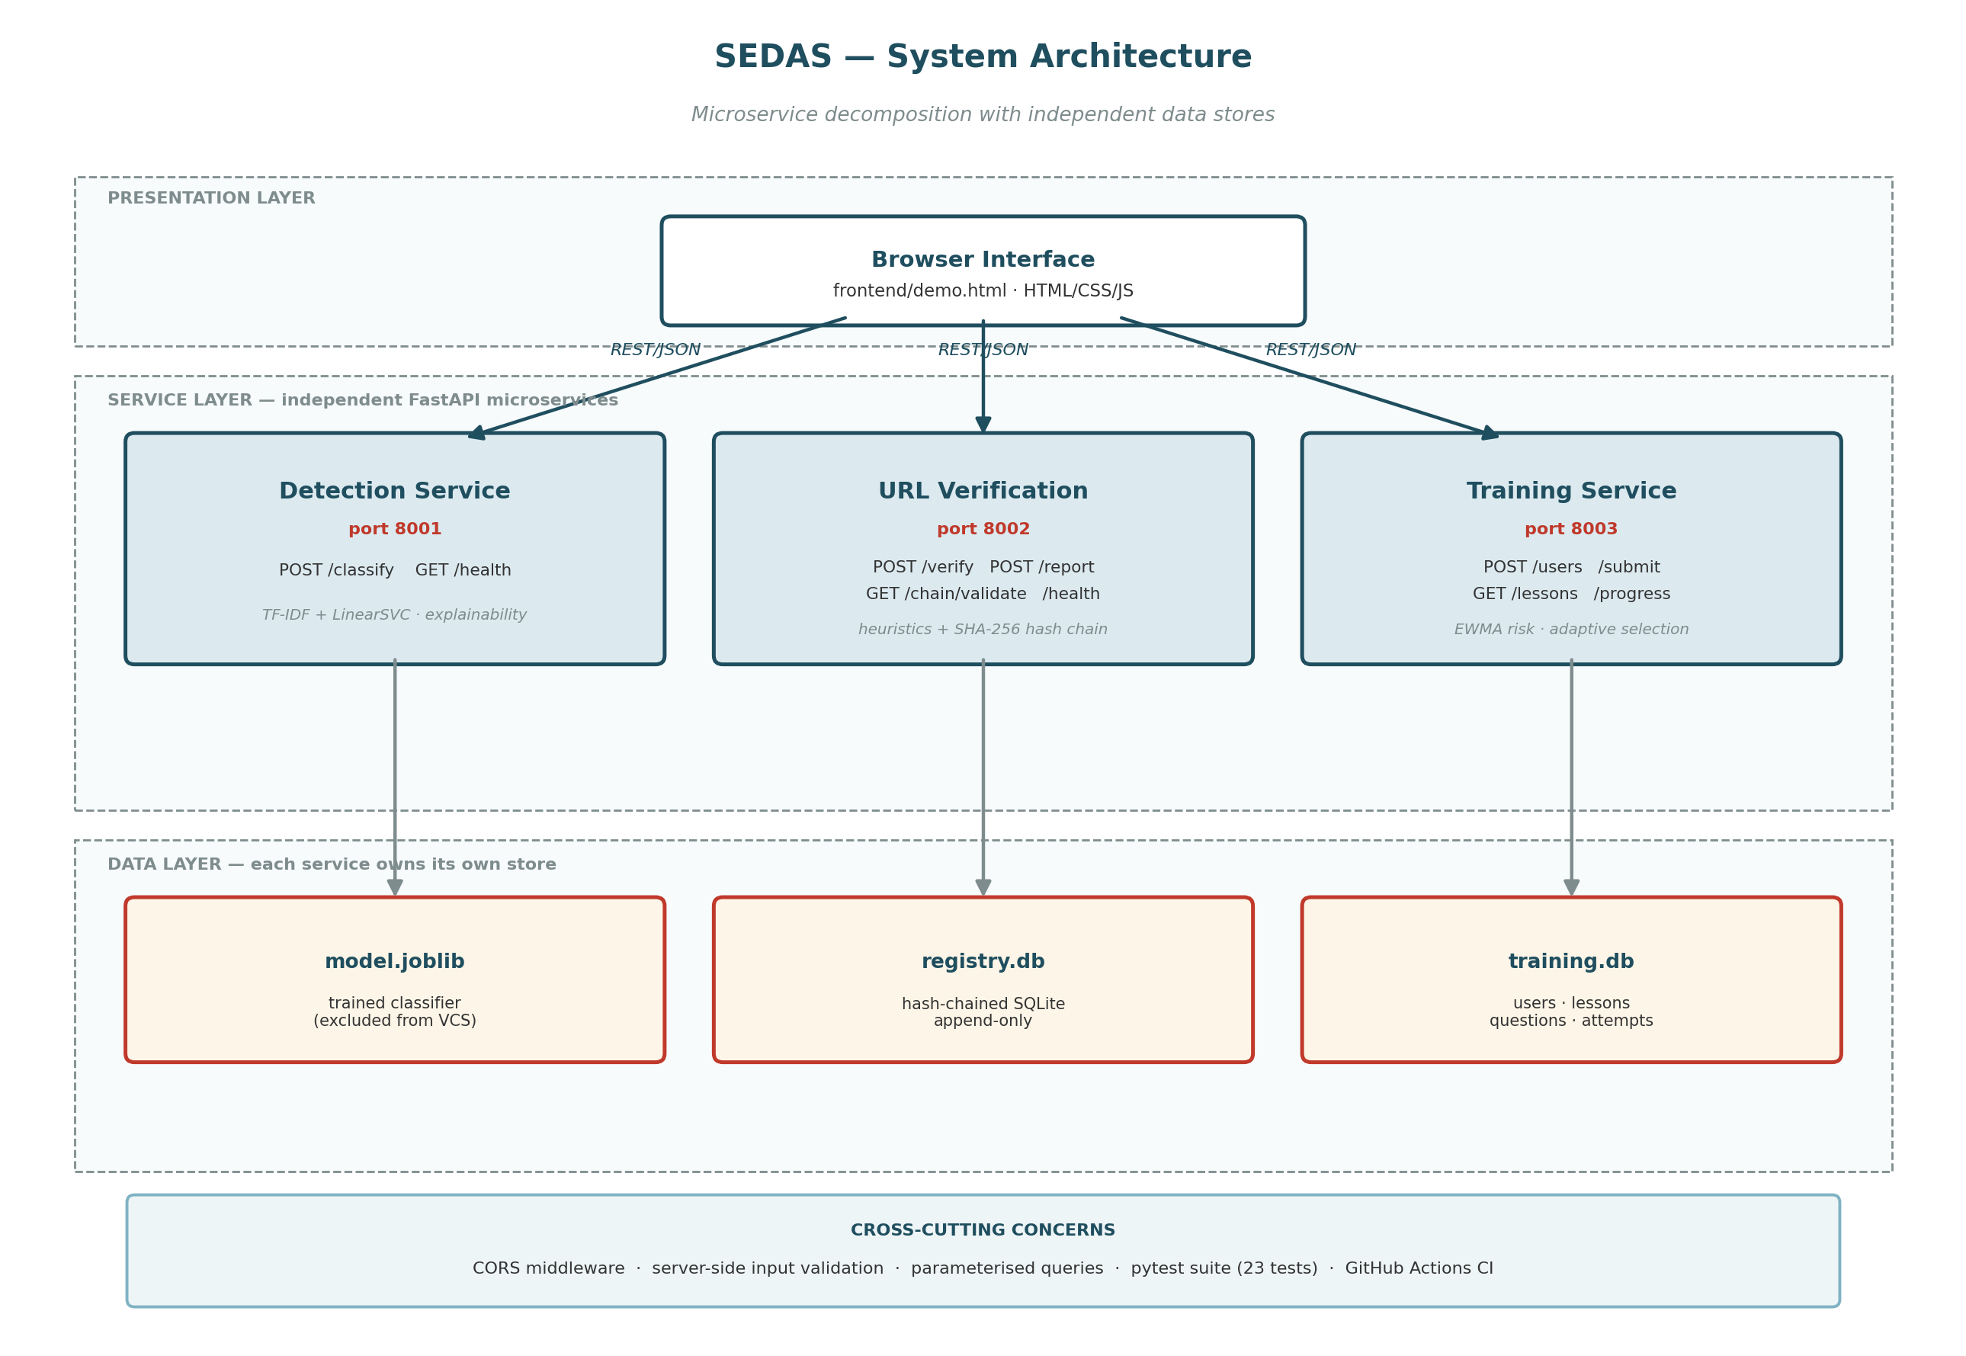
Figure 1: SEDAS system architecture — three-layer decomposition with independent per-service datastores.

2.1 Layer responsibilities
Layer | Responsibility
Presentation | Browser interface collecting user input and rendering verdicts, risk scores, explanatory indicators and registry proofs. Holds no business logic.
Service | Three independent FastAPI applications, each exposing a documented REST API and owning one capability. Services do not call one another; the client orchestrates.
Data | One datastore per service: a serialised model artefact for detection, and separate SQLite databases for the URL registry and training records.

2.2 Rationale for microservice decomposition
The three capabilities have materially different runtime characteristics. Detection is compute-bound and stateless at request time; URL verification is write-heavy with an integrity constraint; training is read-heavy with per-user state. Separating them allows each to be scaled, replaced or secured according to its own profile. The separation also isolates failure: an unavailable training service does not prevent email classification.
The trade-off accepted at MVP scope is operational overhead — three processes must be started rather than one, and there is no service discovery or gateway layer. For a system of this size that cost is acceptable, and the decomposition preserves a clear migration path to container orchestration without redesign.

2.3 Communication
All inter-component communication uses HTTP with JSON payloads. Each service publishes an OpenAPI specification at /docs, generated automatically from the endpoint definitions and request/response models, so the contract is machine-readable and always consistent with the implementation.

3. Technology Stack
Layer | Technology | Purpose
Runtime | Python 3.14 | Application language across all services
Web framework | FastAPI | REST endpoints, request validation, automatic OpenAPI generation
Server | uvicorn | ASGI server hosting each service
Validation | Pydantic | Typed request/response models; rejects malformed input before handler code executes
Machine learning | scikit-learn | TF-IDF vectorisation, LinearSVC, RandomForest, MultinomialNB, LogisticRegression
Gradient boosting | xgboost | XGBoost comparison model
Transformer | PyTorch, Hugging Face Transformers | DistilBERT fine-tuning (preliminary)
Data handling | pandas, scipy | Corpus loading, sparse matrix operations
Persistence | SQLite 3 | Registry and training datastores
Model storage | joblib | Serialisation of the trained classifier pipeline
Hashing | hashlib (SHA-256) | Registry chain integrity
Frontend | HTML, CSS, vanilla JavaScript | Demonstration interface; no build step required
Testing | pytest, FastAPI TestClient | Automated test suite (23 tests)
CI | GitHub Actions | Test execution on every push and pull request
Visualisation | matplotlib | Results figures and diagrams
Table 1: Technology stack by layer.
Note: No dependency requires a GPU. The system is designed to run entirely on commodity CPU hardware, which was a deliberate constraint given the available development environment.

4. Data Model
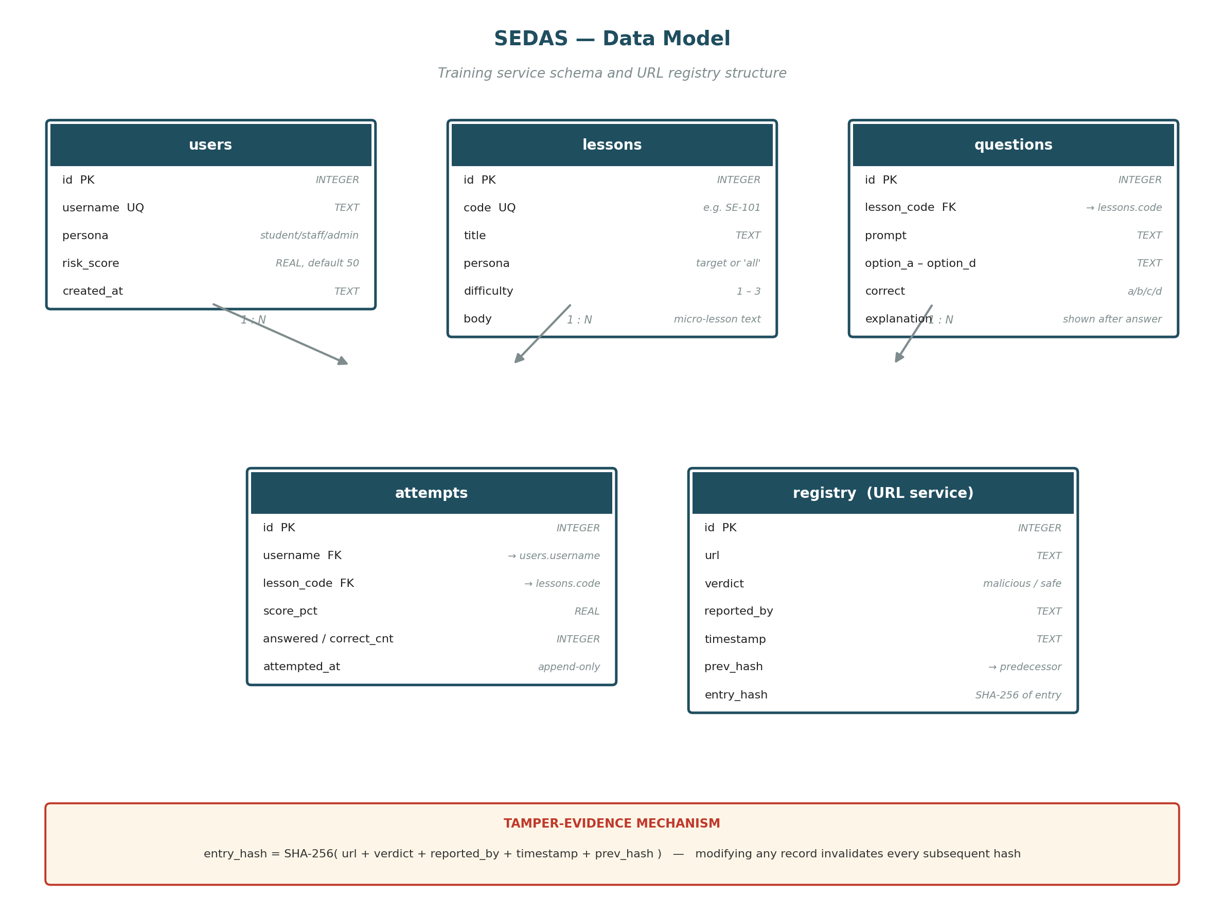
Figure 2: Entity structure for the training service and the URL verification registry.

4.1 Training service schema
Table | Key fields | Notes
users | username (unique), persona, risk_score | persona constrained to student / staff / admin; risk_score defaults to 50.0 (neutral)
lessons | code (unique), persona, difficulty, body | difficulty 1–3; persona may be a specific role or 'all'
questions | lesson_code (FK), prompt, options, correct, explanation | correct and explanation are never returned by the quiz endpoint
attempts | username (FK), lesson_code (FK), score_pct, attempted_at | Append-only; every attempt retained for trend analysis and auditability
Table 2: Training service tables.

4.2 URL registry schema
The registry table stores url, verdict, reported_by, timestamp, prev_hash and entry_hash. Each entry's hash is computed over its own content together with its predecessor's hash:
entry_hash = SHA-256( url + verdict + reported_by + timestamp + prev_hash )

# The first record uses the literal string 'GENESIS' as prev_hash.
Because each hash depends on the one before it, altering any stored record invalidates that record's hash and every subsequent hash in the chain. The /chain/validate endpoint walks the full chain recomputing every hash and reports both validity and, where broken, the position of the first inconsistency.
Note: This provides tamper-evidence, not decentralised consensus. A party with direct database access could recompute the entire chain. Mitigating that requires a distributed ledger or an external anchor, which is documented as future work (refinement R-01).

5. Core Modules

5.1 Detection service
Location: services/detection/. Runs on port 8001.
File | Responsibility
train.py | Loads the corpus, fits the TF-IDF and classifier pipeline, evaluates on the held-out set, persists model.joblib
serve.py | Loads the persisted model and exposes the classification API
compare_models.py | Evaluates five classifiers against the published benchmark
contribution_experiment.py | Engineered-feature and equal-weight ensemble experiments
contribution_experiment_v2.py | Hyperparameter tuning and weighted ensemble experiments
distilbert_preliminary.py | Transformer fine-tuning on a stratified subsample
generate_charts.py | Produces results figures from recorded metrics
Table 3: Detection service modules.
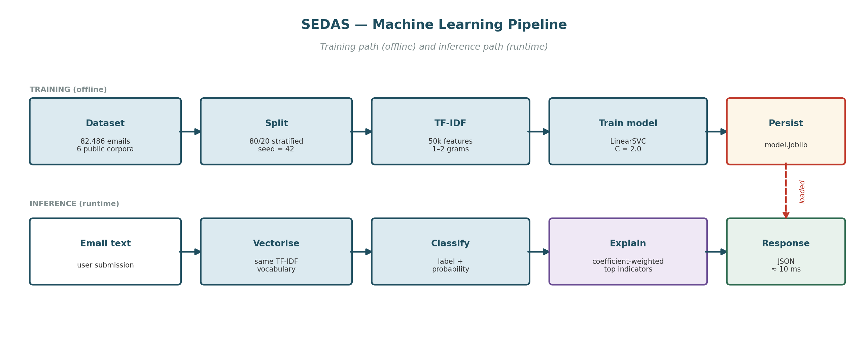
Figure 3: Machine learning pipeline — offline training path and runtime inference path.

Endpoints
Endpoint | Method | Behaviour
/classify | POST | Accepts email text; returns label, risk score 0–100, top contributing indicators, measured latency
/health | GET | Returns service status for monitoring

Explainability mechanism
For a submitted email, the request's TF-IDF vector is multiplied element-wise by the trained classifier's coefficient vector. The resulting products give each present term's signed contribution to the decision. The five largest positive contributions are returned as the indicators that drove a phishing classification.

5.2 URL verification service
Location: services/url-verify/. Runs on port 8002.

Heuristic indicators
Indicator | Rationale
No HTTPS | Unencrypted transport for a credential-collecting page
Raw IP address as host | Legitimate services almost always use domain names
'@' in URL | Everything before '@' is discarded by browsers, hiding the true destination
Multiple hyphens in domain | Common in lookalike domains imitating a legitimate brand
Excessive subdomain depth | Used to place a trusted-looking name in a subdomain of an attacker domain
High-risk TLD | Certain TLDs are disproportionately represented in abuse data
Known URL shortener | Destination cannot be inspected before clicking
Abnormal length | Long URLs obscure the destination in address bars
Credential-lure keywords | Terms such as login, verify, secure, account, password
Table 4: URL heuristic indicators and their rationale.

Endpoints
Endpoint | Method | Behaviour
/verify | POST | Returns verdict, registry status, chain proof, heuristic score and findings
/report | POST | Appends a verdict to the registry; returns the new entry hash
/chain/validate | GET | Recomputes the full chain; returns validity and entry count
/health | GET | Returns service status
Verdict resolution combines both layers: a URL previously reported malicious returns 'blocked'; a URL reported safe with a low heuristic score returns 'trusted'; an unreported URL scoring at or above the threshold returns 'suspicious'; otherwise 'low_risk'.

5.3 Awareness training service
Location: services/training/. Runs on port 8003.

Scoring engine
Function | Behaviour
score_attempt(correct, answered) | Returns percentage score to one decimal place; returns 0.0 when no questions were answered
update_risk(current, score) | Exponentially weighted moving average with ALPHA = 0.4, clamped to 0–100
risk_band(risk) | Maps risk to low (<33), medium (<66) or high
next_lesson_for(...) | Filters by persona, excludes completed lessons, targets difficulty by risk band, falls back to any remaining eligible lesson
Table 5: Training service scoring engine functions.
# Risk update - EWMA
new_risk = (1 - ALPHA) * current_risk + ALPHA * (100 - score_pct)

# A high quiz score produces a low risk contribution.
# ALPHA = 0.4 weights recent behaviour without allowing a single
# poor attempt to erase a sustained good record.
Lesson difficulty is deliberately inverted against risk: high-risk users receive difficulty 1 content, low-risk users receive difficulty 3. Reinforcing foundations is more effective for a struggling learner than escalating difficulty, while a confident learner requires more advanced material to remain engaged.

Endpoints
Endpoint | Method | Behaviour
/users | POST | Registers a user with a persona; returns 409 if the username exists
/lessons | GET | Lists lessons, optionally filtered by persona
/lessons/{code}/quiz | GET | Returns prompts and options only — correct answers withheld
/submit | POST | Marks the attempt, records it, updates risk, returns per-question feedback
/progress/{username} | GET | Returns risk score and band, completed lessons, attempt history, recommended next lesson
/health | GET | Returns service status

6. Security Controls
Control | Implementation | Verified by
Injection prevention | Parameterised queries throughout; no string concatenation into SQL | TS-01
Input validation | Pydantic models reject malformed requests with HTTP 422 before handler execution | TS-02, TS-02b
Answer confidentiality | Quiz endpoint projects only prompt and option fields; correct answers never leave the server | TS-04
Integrity | SHA-256 hash chaining over registry entries; full-chain revalidation endpoint | TS-06, TU-03
Error handling | Unknown resources return 404 with a descriptive message rather than a server error | TS-03, TS-03b
Secret management | No credentials in version control; .env.example pattern with environment variables | Repository inspection
Data exclusion | Datasets, model binaries and databases excluded via .gitignore | Repository inspection
Service monitoring | Health endpoint on every service | TS-05
Table 6: Implemented security controls and the tests that verify them.

6.1 Known limitations
- Access control — No authentication or role-based access control is implemented at MVP scope. Any party able to reach a service endpoint can invoke it. Production deployment assumes institutional single sign-on in front of the services.
- CORS — CORS is configured permissively (allow_origins set to all) to support the local demonstration interface opened as a file. This must be restricted to known origins before any deployment.
- Rate limiting — No rate limiting is applied to the report endpoint, which could permit registry poisoning through mass false submissions.

7. Deployment and Execution

7.1 Prerequisites
- Python 3.12 or later
- Git
- Approximately 2 GB free disk space (dependencies and, optionally, the training corpus)

7.2 Installation
git clone https://github.com/ailinkon/MIS5320-SEDAS-CyberProjectB.git
cd MIS5320-SEDAS-CyberProjectB

python -m venv venv

# Windows PowerShell
.\venv\Scripts\activate
# macOS / Linux
source venv/bin/activate

pip install -r requirements.txt
Note: On Windows, PowerShell may block the activation script. If so, run once: Set-ExecutionPolicy -ExecutionPolicy RemoteSigned -Scope CurrentUser

7.3 Data and model preparation
The training corpus and the trained model are excluded from version control. Both must be prepared before the detection service can start.
# 1. Download the dataset from Kaggle:
# naserabdullahalam/phishing-email-dataset
# Place phishing_email.csv at:
# services/detection/data/phishing_email.csv

# 2. Train the model (approximately 2-4 minutes on CPU)
python services/detection/train.py

# 3. Seed the training content library
python services/training/seed_content.py

7.4 Starting the services
Each service runs in its own terminal session, with the virtual environment activated in each.
# Terminal 1 - detection service
uvicorn services.detection.serve:app --reload --port 8001

# Terminal 2 - URL verification service
uvicorn serve:app --reload --port 8002 --app-dir services/url-verify

# Terminal 3 - awareness training service
uvicorn serve:app --reload --port 8003 --app-dir services/training
The frontend requires no server: open frontend/demo.html directly in a browser.

7.5 Verifying the installation
Check | Expected result
http://127.0.0.1:8001/docs | Detection service OpenAPI page loads
http://127.0.0.1:8002/docs | URL verification OpenAPI page loads
http://127.0.0.1:8003/docs | Training service OpenAPI page loads
pytest tests/ -v | 23 tests pass (5 skip if the model has not been trained locally)
Table 7: Post-installation verification steps.

7.6 Running the experiments
# Five-model benchmark comparison against the published paper
python services/detection/compare_models.py

# Optimisation experiments
python services/detection/contribution_experiment.py
python services/detection/contribution_experiment_v2.py

# Transformer comparison (preliminary; 30-60 minutes on CPU)
python services/detection/distilbert_preliminary.py

# Regenerate results figures
python services/detection/generate_charts.py

8. Repository Structure
MIS5320-SEDAS-CyberProjectB/
├── .github/workflows/ci.yml GitHub Actions pipeline
├── services/
│ ├── detection/ classification service and experiments
│ │ ├── data/ corpus (excluded from VCS)
│ │ ├── train.py
│ │ ├── serve.py
│ │ ├── compare_models.py
│ │ ├── contribution_experiment.py
│ │ ├── contribution_experiment_v2.py
│ │ ├── distilbert_preliminary.py
│ │ └── generate_charts.py
│ ├── url-verify/
│ │ └── serve.py heuristics and hash-chained registry
│ └── training/
│ ├── schema.sql database schema
│ ├── seed_content.py lesson and question library
│ └── serve.py scoring engine and API
├── frontend/demo.html demonstration interface
├── tests/ 23 automated tests
│ ├── test_detection.py TD-01..05
│ ├── test_url_verify.py TU-01..03
│ ├── test_training.py TT-01..06
│ └── test_security.py TS-01..06
├── docs/ documentation, minutes, evidence, figures
├── conftest.py pytest path configuration
├── requirements.txt
└── PROJECT_LOG.md
Note: Both the URL verification and training services define a module named serve. Test modules must therefore load them explicitly by file path using importlib rather than by module name, otherwise Python returns whichever module was imported first. This is implemented in tests/test_security.py and tests/test_url_verify.py.

9. Testing
Suite | Test IDs | Coverage | Requirements
Detection | TD-01..TD-05 | Health, phishing detection, legitimate pass-through, explainability, latency | FR-01, FR-02, FR-09, NFR-03
URL verification | TU-01..TU-03 | Heuristic flagging, report-then-blocked, chain integrity | FR-03, FR-04
Training | TT-01..TT-06 | Scoring, EWMA risk, banding, adaptive selection, fallback | FR-05, FR-06
Security | TS-01..TS-06 | Injection, malformed input, unknown resources, answer confidentiality, health, chain integrity | NFR-05
Table 8: Test suite structure. Total 23 tests.
Model-dependent tests skip cleanly when the trained model is absent, allowing the continuous integration pipeline to execute the remaining suites on a clean checkout without requiring the corpus or a trained artefact.

